Herrera, Mark Daniel L.
BSIT 2-F1
Exercise 10

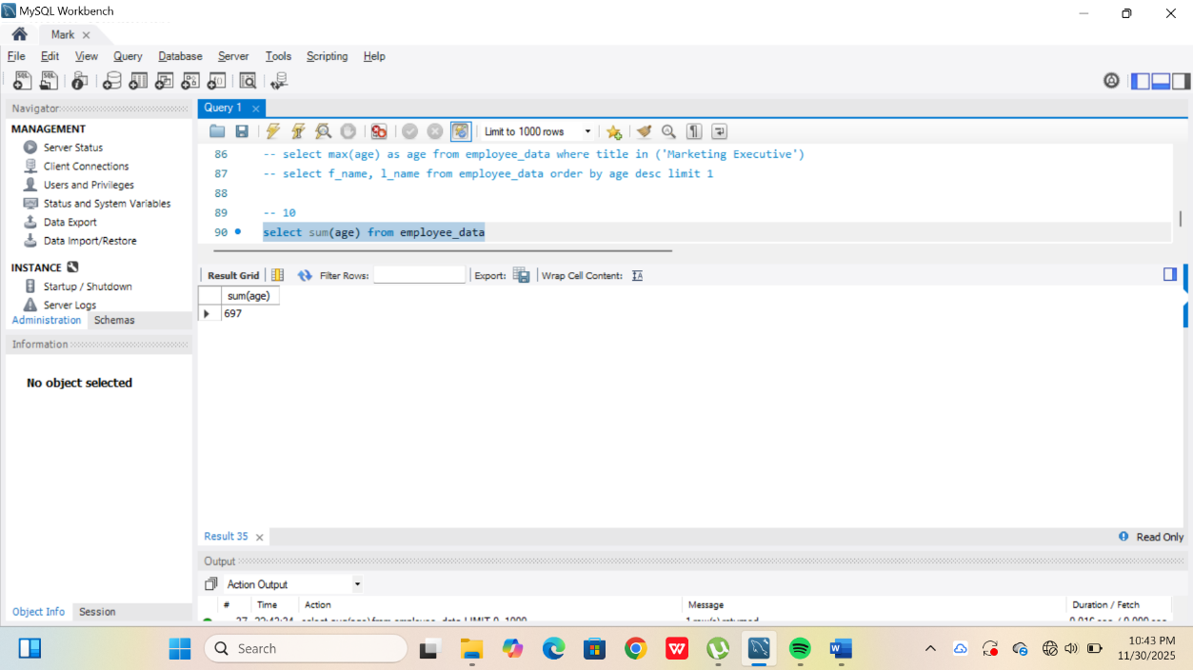
- Select SUM(yos) from employee_data
- 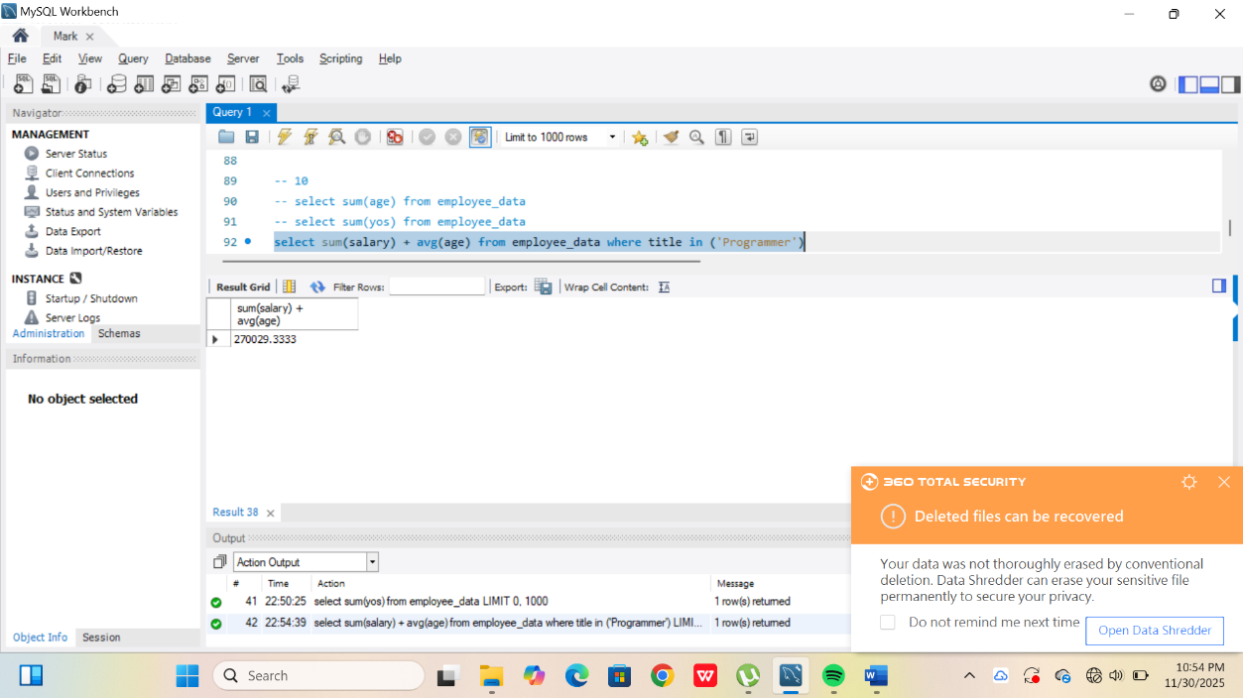
- In the statement, it calculates the sum of perks and divide from sum of the salary and multiply it from 100 where the answer is 16.8317.

